Secure Application Programming
Project Template

Student Name:
Student Number:
Module:
Date:

Revisions

Version | Primary Author | Description of Version | Date Completed
V1.0

Table of Contents

Table of Contents
Software Development Lifecycle Methodology 2
Introduction 2
Software Requirement Specification: 3
General Description: 3
Requirements : 3
Functional Requirements: 3
Non-Functional Requirements: 3
Data Classification: 4
Entity Relation Diagram (ERD): 4
Technical Specification: 5
High-Level Architectural Diagram 5
Wireframes: 5
Use-Case Diagram: 7
Use-Case Description: 8
Class Diagram: 12
Sequence Diagram: 12
Testing Plan 13
Discussion on the Insecure Code: 13
Discussion on the Secure Code: 13
Ethics Question: 13
Appendix A Breakdown of Marks 14
Appendix B 14

Software Development Lifecycle Methodology
Choose two Methodologies from the following list. Provide an explanation of your understanding of both. Make a detailed comparison of each and provide a justification why you would use one over the other.
- Waterfall:
- Agile Iterative Model:
- Spiral Model:
- V Model:
- Rapid Application Model:

Introduction

In this project you are required to evaluate develop and implement an open-source web application that will use ether Node with Express or PHP. The database for simplicity should be SQLite3. This web application does not need to be hosted.

There should be two implementations of you application, The insecure version should contain the following.

SQL Injection flaw
Cross Site Scripting XSS vulnerability: Reflected, DOM Based and Stored.
Sensitive Data Exposure.

The Secure version of your application should rectify these vulnerabilities by providing a detailed explanation of how it was done in addition it should have the following.

Cross Site Requested Forgery Token.
Proper Session Management incorporated.
Use of Security Headers
Adequate logging and monitoring incorporated into the application.

The Web Application should be as simple as possible. This project is intended to test your understanding of secure programming concepts, not building web applications UI UX design is not important but what is important is the documentation on how you approached the design implementation and testing of the project. You may ask your fellow students to perform a code review, but this is optional and will not be marked.

The Code should be made available on GitHub. The secure and insecure versions should be separated into two branches secure branch and insecure branch, use the README.md file to provide details of any setup configuration required to run your code, and use git issues and Git Project to demonstrate project planning and implementation.

Software Requirement Specification:

General Description:
Give a brief description of your web application. keep it simple it can be a Blog Post or TO-DO list with different levels of access rights. The purpose is to demonstrate SQL Injection, XSS Vulnerabilities and Sensitive Data exposure. In the secure version you will need to provide proper logging and monitoring, Session Management, secure headers and CSRF to improve security.

Write a short paragraph describing the web application that you will build.

Describe how you can incorporate Secure Application Principles into the project.
- Principle of Least Privilege
- Principle of Secure Defaults
- Principle of Fail Securely
- Principle of Separation of Duties
- Principle of Defense in Dept

Requirements :
Define your web application. Describe what you are building. Set out the product scope by detailing what it can and cannot do.

Functional Requirements:
Describe the Functional requirements these describe what the software should do for example.

- The web application should offer the ability to create a user account.
- The web application should allow the user to create a blog post.
- The web application should allow the user the ability to edit their blog post.
- The web application should allow an administrator the ability to delete a blog post.

The purpose of the functional requirements is to understand and define what is required from the software. Requirement validation aims to verify that the collected requirements are complete and free of errors. These requirements will be the basis of the Use-Case diagram and Use Case Descriptions.

Non-Functional Requirements:
Non-Functional Requirements define how well a software should perform they cover areas such as speed, security reliability and useability. The requirements for your web application should be Specific Measurable Attainable Relevant and Time-bound SMART. Use the chrome developer tools lighthouse feature to assist you with this section. This can provide report on the following.
- Performance.
- Accessibility
- Search Engine Optimisation SEO
- Best Practices

Data Classification:
Many frameworks and legal regulators have specific requirement to classify the data that is held by an organisation.

GDPR defines personal data as any information that can identify a natural person as, names, location data, online identifiers, email or IP addresses to comply with the law it is required to classify data in terms of the type of information being held financial, health etc, the basis for holding the data personal or sensitive where additional level of protection is required for race, ethnic origin, political opinion, biometric data, health data., The user has the right to know what data is held on them and has the right to be forgotten. When designing a web application, it worth incorporating features that would allow compliance with the law.

California Consumer Privacy Act gives citizens the right to request information about what types of data that is held and the right to request deletion of personal data.

Special precautions should be applied to the following types of data.
- Personally Identifiable Information PII
- Personal Health Information PHI

The first step is to create a catalogue of data that will be held and to put in place security features to prevent sensitive data exposure.

Type Of Data | Basis for collection | Security features to protect

Entity Relation Diagram (ERD):
Consider the type of data required to build your web application and create an ERD diagram.
What information is required for a user to log in Name, Email, Password are you incorporating a security principle that allows a user so many attempts before being logged out are you separating the content of your site depending on the age of the user. What would the table look like if it was displaying blog posts or a TO-DO list?

Tip this is not a real website that you are building this is an exercise in how to create an insecure and a secure web application that has a SQL injection, a stored XSS vulnerability and needs to incorporate elements of session management so think of the database in terms of how best to achieve this. Think of the security principles and how these can best be incorporated into your project will you use a hash for the user password will you be using different hashing algorithm? will you be using a database for proper logging of your application what would that table look like?

Technical Specification:
A short paragraph introducing the technical aspects of your project.

High-Level Architectural Diagram
Provide a high-level architectural diagram of the application describing the technologies that you intent to use. Node or PHP.

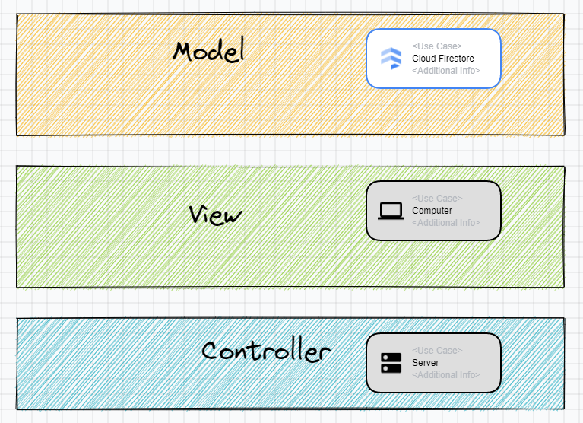

Provide a short paragraph describing this diagram.

Wireframes:
Provide a wireframe of each page in your application this will help you when you come to fill out your Use-Case Description.



Page 1

Page 2

Page 3

Use-Case Diagram:
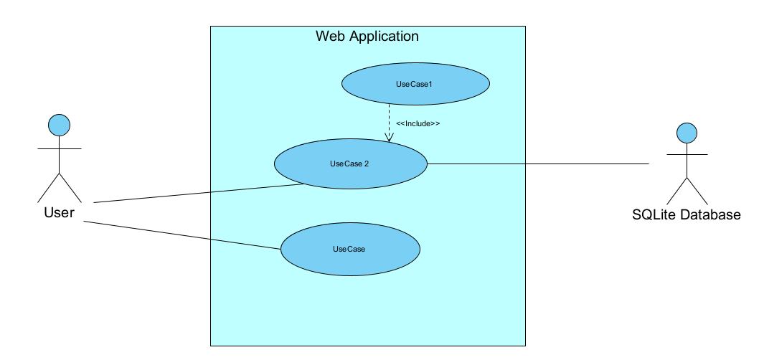
Keep use-case diagrams simple the important things to remember.
- Use-Cases are described from the perspective of the main user.
- What’s inside the system box is under your control.
- Use-case name Verb Noun if the most important aspect of this UML it should be obvious to the reader what is its function.
- For every use-case in the use-case diagram there must be a use-case description. DO NOT include ovals in this diagram that parr of the use case description this is a high-level overview of the system.
- The Use-Case name must match in the use case description.
- Includes Use-Case is part of the DRY Don’t repeat yourself principle and they must always be called.
- If you find yourself with too many use-cases in the diagram you are defeating the purpose of the diagram. As a rule of thumb keep the number of use-cases to around seven if your system requires more consider splitting into more than one use-case diagram.

Use-case | Use-Case Name | Description
UC-1
UC-2
UC-3
UC-4

Use-Case Description:
Provide a brief description of each use case remember the use-case names must match the name in the use case diagram.

Use Case ID:
Use Case Name:
Created By: |  | Last Updated By:
Date Created |  | Last Updated Date
Description:

Actors:
Primary
Secondary

Triggers:

Pre-conditions:

Post-Conditions:

Normal Flow:

Alternate Flows:

Exceptions:

Includes:

Extends:

Priority:

Special Conditions:

Assumptions:

Notes and Issues:

Use Case ID:
Use Case Name:
Created By: |  | Last Updated By:
Date Created |  | Last Updated Date
Description:

Actors:
Primary
Secondary

Triggers:

Pre-conditions:

Post-Conditions:

Normal Flow:

Alternate Flows:

Exceptions:

Includes:

Extends:

Priority:

Special Conditions:

Assumptions:

Notes and Issues:

Use Case ID:
Use Case Name:
Created By: |  | Last Updated By:
Date Created |  | Last Updated Date
Description:

Actors:
Primary
Secondary

Triggers:

Pre-conditions:

Post-Conditions:

Normal Flow:

Alternate Flows:

Exceptions:

Includes:

Extends:

Priority:

Special Conditions:

Assumptions:

Notes and Issues:

Use Case ID:
Use Case Name:
Created By: |  | Last Updated By:
Date Created |  | Last Updated Date
Description:

Actors:
Primary
Secondary

Triggers:

Pre-conditions:

Post-Conditions:

Normal Flow:

Alternate Flows:

Exceptions:

Includes:

Extends:

Priority:

Special Conditions:

Assumptions:

Notes and Issues:

Class Diagram:
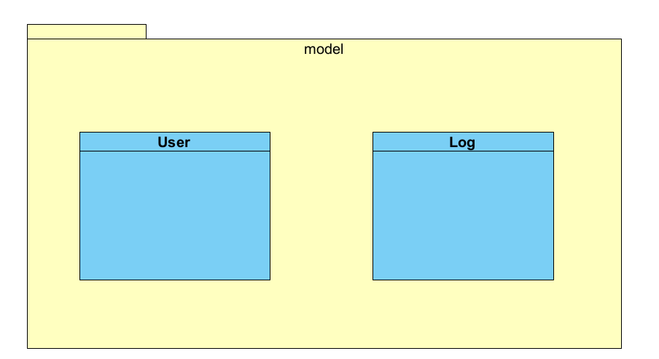
Demonstrate you understanding of Design patterns by incorporating a few of them for example Singlton or Observer patterns. In your code use The Don’t Repeat Yourself (DRY) and Solid principles. Explaining how you used the in code.

Sequence Diagram:

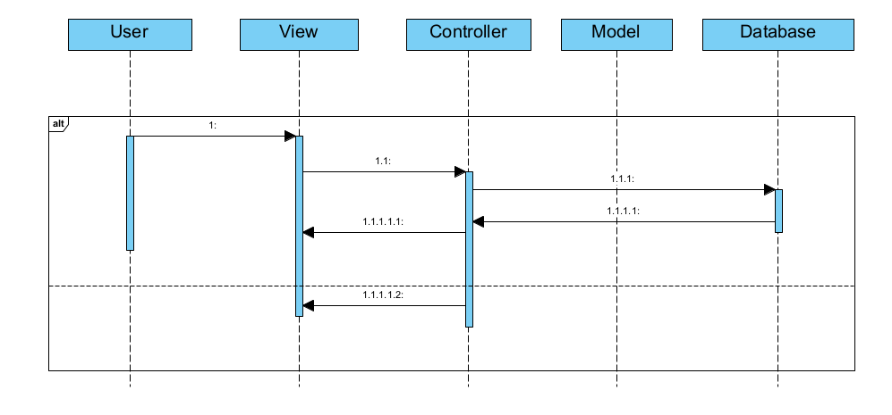
Describe the sequence of messages outlined in the sequence diagram.

Testing Plan
Create a testing plan is based on the normal, Alternate and Exceptional flows in each Use Case Description.

Provide details of the results of this plan.

Use Selenium or Playwright to create tests of your application.

Test the Non-Function requirements of your App using the Chrome developer tools.

Carry out DAST testing on both the Secure and Insecure Branches of your Code using ZAP.
Highlight any Vulnerabilities raised by the tool.

Discussion on the Insecure Code:
Explain the following vulnerabilities and illustrate how you implemented them in your application. Reference the OWASP Top 10 in your answer.
- SQL Injection.
- XSS.
- Sensitive Data Exposure.

Why are they so dangerous?
How a hacker could exploit these vulnerabilities
Provide screen shots of the code.
Provide a screen shot of these vulnerabilities in action in your application.

Discussion on the Secure Code:
Explain how you secured your application from the SQL injection XSS vulnerability and how use mitigated the Sensitive Data Exposure. Reference the OWASP Cheat sheets as to the available options to secure the application.

Discuss how you incorporated proper logging and monitoring. Make a reference to the
What security headers were added and explain why they improved the security.

Ethics Question:
You are working as a contractor in a large software development company you like the work and the organisation and any future work will depend on how you get on with the lead developer. During the final stage of the project, you are tasked with alpha testing and performing a code review where you discover a major vulnerability that would seriously affect the confidentiality integrity and availability of sensitive data held by the organisation. This discovery was only possible because of a penetration test that you had performed for a different client but as part of that test, you signed a letter of engagement which included a non-disclosure clause. You advised the lead developer of your findings and because of a lack of time to fix that problem, he does not want to do anything about it.
Consider three of the Software Engineering Code of Ethics principles and describe what you are going to do about the ethical issues raised by this scenario.

Answer

Appendix A Breakdown of Marks
Section | Description | % mark
1 | Software Development Lifecycle justification | 10%
2 | Software Requirement Specification | 20%
3 | The Use of GitHub for code and project planning | 5%
4 | Discussion of Insecure code implementation | 20%
5 | Discussion of Secure code implementation | 20%
6 | Testing Documentation and results | 10%
7 | Short video demonstrating your project | 5%
8 | Ethics | 10%

Appendix B
Link to GitHub:

Link to Video Demonstration:

